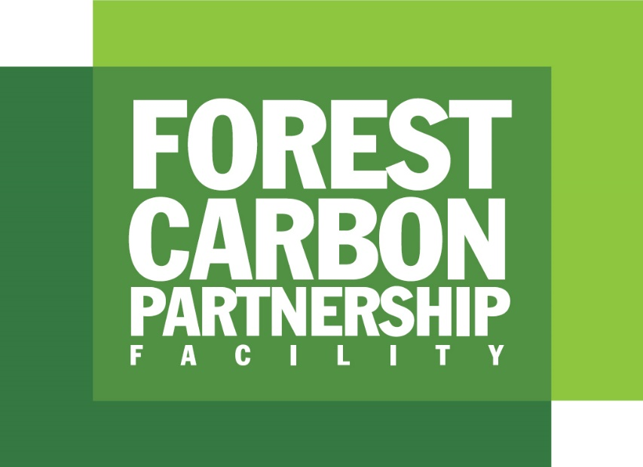

Readiness Fund REDD+ Country Participants Progress Report Template

v. 2019

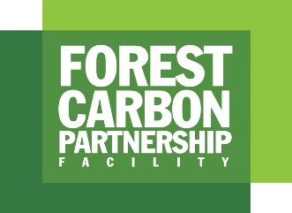

FCPF Readiness Fund:
REDD+ Country Participant Annual Progress Report
About this document
This template is for use by Readiness Fund (RF) REDD+ Country Participants to report their annual progress on REDD+ readiness activities in general, and on FCPF-supported activities in particular. The data provided through these reports represents a central information source for measuring progress against the FCPF’s expected results and performance indicators, as articulated within the FCPF Monitoring and Evaluation (M&E) Framework.
Report preparation
Reports cover progress through 30th June of each year.
When preparing the report, RF REDD+ Country Participants should draw upon the country M&E system for REDD+ (component 6 of the R-PP) and should consult members of the national REDD task force or equivalent body. Inputs from stakeholders including IPs and CSOs should be integrated, with any divergent views recorded as appropriate. Detailed, indicator-by-indicator definitions and reporting guidance are provided within the FCPF M&E Framework (https://www.forestcarbonpartnership.org/monitoring-and-evaluation-0).
Reporting schedule
Completed reports should be submitted to the FCPF’s Facility Management Team (FMT) by 15th July every year.

SECTION A: NARRATIVE SUMMARY

- In brief, what were the main REDD+ readiness-related activities and achievements delivered within your country during the last year?
- Activities - For example, strategy / policy drafting, stakeholder consultation events, capacity building / training, awareness raising initiatives
- Achievements - For example, x number of individuals attended REDD+ consultations (sex disaggregated, if available), national REDD+ strategy was finalised, government formally adopted national REDD+ related policy/s, NFMS was established, partnership agreement with private sector association signed
- Please be as specific as possible, e.g. name, date and number of participants in consultation events (sex disaggregated, if available), name of policy being drafted, institutions involved in policy drafting

- What were the main REDD+ readiness-related challenges and/or problems during the last year?
- For example, lack of engagement from key stakeholders, political barriers, limited funding

- What are the main REDD+ readiness-related activities that you hope to deliver, and achievements anticipated during the next year?
- For example, hold x consultation events, submission of R-Package to the PC, finalisation of SIS, commission research into REDD+ strategy options

SECTION B: READINESS PROGRESS

- Please provide your own assessment of national progress against all REDD+ readiness sub-components:
(Indicator OV.1.B: Number of FCPF supported countries that have in place a National REDD+ Strategy, FREL/FRL, NFMS and SIS; Output 1.3 indicators)

Progress rating key:
Complete | The sub-component has been completed
 | Significant progress
 | Progressing well, further development required
 | Further development required
 | Not yet demonstrating progress
N/A | The sub-component is not applicable to our process

Sub-component | Progress rating  (mark ‘X’ as appropriate) |  | Narrative assessment (briefly explain your rating)
R-PP Component 1: Readiness Organisation and Consultation
Sub-component 1a:  National REDD+ Management Arrangements | Complete
 | N/A
Sub-component 1b:  Consultation, Participation and Outreach | Complete
 | N/A
R-PP Component 2: REDD+ Strategy Preparation
Sub-component 2: REDD+ Strategy | Complete
 | N/A
Sub-component 2a:  Assessment of Land Use, Land Use Change Drivers, Forest Law, Policy and Governance | Complete
 | N/A
Sub-component 2b:  REDD+ Strategy Options | Complete
 | N/A
Sub-component 2c:  Implementation Framework | Complete
 | N/A
Sub-component 2d:  Social and Environmental Impacts | Complete
 | N/A
R-PP Component 3: Reference Emissions Level/Reference Levels
Component 3:  Reference Emissions Level/Reference Levels | Complete
 | N/A
R-PP Component 4: Monitoring Systems for Forests and Safeguards
Sub-component 4a:  National Forest Monitoring System | Complete
 | N/A
Sub-component 4b:  Information System for Multiple Benefits, Other Impacts, Governance, and Safeguards | Complete
 | N/A

SECTION C: NON-CARBON BENEFITS

- Does your national REDD+ Strategy or Action Plan include activities that directly aim to sustain and enhance livelihoods (e.g. one of your program objective/s is explicitly targeted at livelihoods; your approach to non-carbon benefits explicitly incorporates livelihoods)?
(Indicator 3.2.b: Number of RF REDD+ Country Participants whose REDD+ Strategies include activities that directly aim to sustain and enhance livelihoods)

Yes | No | (delete as appropriate)

If yes, please provide further detail, including attachments and/or references to the documentation that outlines your approach:

- Does your national REDD+ Strategy or Action Plan include activities that directly aim to conserve biodiversity (e.g. one of your program objective/s is explicitly targeted at biodiversity conservation; your approach to non-carbon benefits explicitly incorporates biodiversity conservation)?
(Indicator 3.3.b: Number of RF REDD+ Country Participants whose REDD+ Strategies include activities that directly aim to conserve biodiversity)

Yes | No | (delete as appropriate)

If yes, please provide further detail, including attachments and/or references to the documentation that outlines your approach

SECTION D: FINANCE
(Please complete in US$ ONLY)

- Please detail the amount of all finance received in support of development and delivery of your national REDD+ readiness process since the date that your R-PP was signed. Figures should only include secured finance (i.e. fully committed) – ex ante, (unconfirmed) finance or in-kind contributions should not be included:
(Indicator 1.B: Amount of finance received to support the REDD+ Readiness process (disaggregated by public, private, grants, loans))

Amount  (US$) | Source  (e.g. FCPF, FIP, name of gov’t department) | Date committed  (MM/YY) | Public or private finance?  (Delete as appropriate) | Grant, loan or other?  (Delete as appropriate)
EXAMPLES:
$500,000 | FCPF Readiness Preparation Grant | 10/2013 | Public / Private | Grant / Loan / Other
$250,000 | Ministry of Forestry | 01/2014 | Public / Private | Grant / Loan / Other
$ |  |  | Public / Private | Grant / Loan / Other
$ |  |  | Public / Private | Grant / Loan / Other
$ |  |  | Public / Private | Grant / Loan / Other
$ |  |  | Public / Private | Grant / Loan / Other
$ |  |  | Public / Private | Grant / Loan / Other
$ |  |  | Public / Private | Grant / Loan / Other

- Please detail any ex ante (unconfirmed) finance or in-kind contributions that you hope to secure in support of your national REDD+ readiness process:

Amount  (US$) | Source  (e.g. FCPF, FIP, name of gov’t department) | Public or private finance?  (Delete as appropriate) | Grant, loan or other?  (Delete as appropriate)
$ |  | Public / Private | Grant / Loan / Other
$ |  | Public / Private | Grant / Loan / Other
$ |  | Public / Private | Grant / Loan / Other
$ |  | Public / Private | Grant / Loan / Other
$ |  | Public / Private | Grant / Loan / Other
$ |  | Public / Private | Grant / Loan / Other

SECTION E: FCPF PERFORMANCE

- To help build an understanding of the FCPF strengths, weaknesses and contributions to REDD+, please indicate the extent to which you agree with the following statements:
(Indicator 4.B: Participant Countries' assessment of FCPF's role within and contribution to national REDD+ processes)
 | Mark ‘X’ as appropriate
 | Completely disagree | Disagree | Neutral | Agree | Completely agree
The FCPF’s support has had a central influence on the development our national REDD+ systems and processes
The FCPF’s support has improved the quality of our national REDD+ systems and processes
The FCPF’s support has improved national capacities to develop and deliver REDD+ projects
The FCPF’s support has helped to ensure substantive involvement of multiple stakeholders (including women, IPs, CSOs and local communities in our national REDD+ systems and processes

Comments / clarifications, if appropriate:

- To help assess the usefulness and application of FCPF knowledge products (publications, seminars, learning events, web resources), please indicate the extent to which you agree with the following statements:
(Indicator 4.3.a: Extent to which FCPF learning, evidence and knowledge products are used by Participant countries)
 | Mark ‘X’ as appropriate
 | Completely disagree | Disagree | Neutral | Agree | Completely agree
We regularly access FCPF knowledge products to obtain REDD+ related information
FCPF knowledge products are relevant to our REDD+ related information requirements
FCPF knowledge products are sufficient to address all of our REDD+ related information requirements
The FCPF website is a useful resource for accessing FCPF and REDD+ related information

Comments / clarifications, if appropriate:

SECTION F: FINAL COMMENTS

- If appropriate, please provide any further comments or clarifications relating to your work on REDD+ Readiness during the last year:

